ECE3810 Microprocessor System Design Laboratory

Laboratory Report 5

Name: Xu Zigeng
Student ID: 123090704
Date: 2025/11/25

The Chinese University of Hong Kong, Shenzhen
During this lab, the following experiments were conducted to understand and implement the Timer system on the Cortex-M3 processor, focusing on General Purpose Timers (TIM3, TIM4), System Tick Timer (SysTick), Pulse Width Modulation (PWM), and timer-based input acquisition (JOYPAD).
- Experiment A: Configure TIM3 to generate a periodic interrupt to toggle an LED (DS0) at a fixed frequency.
- Experiment B: Incorporate a second timer (TIM4) to control a second LED (DS1) and synchronize their flashing behaviors.
- Experiment C: Configure the SysTick timer to generate a system heartbeat (10ms tick) for multi-tasking scheduling.
- Experiment D: Implement PWM using TIM3 Channel 2 to drive an LED with variable brightness (breathing light).
- Experiment E: Utilize TIM3 to periodically poll the JOYPAD input status and display the pressed key on the LCD

- Experiment A
  - Design
The objective was to use the General Purpose Timer TIM3 to generate an interrupt twice per second, creating a 1 Hz flashing effect on LED DS0. ⁶⁶⁶
The system clock was initialized to 72 MHz. The timer period is determined by the Prescaler (PSC) and Auto-Reload Register (ARR).
The design followed the initialization sequence:
- Enable the clock for TIM3 by setting bit 1 in RCC->APB1ENR.
- Set TIM3->PSC to 7199 and TIM3->ARR to 4999.
- Enable the Update Interrupt by setting the UIE bit (bit 0) in TIM3->DIER.
- Enable the counter by setting bit 0 in TIM3->CR1.
- Configure NVIC priority for TIM3 (Position 29) to 0x45 (Pre-emption 2, Subpriority 1) in NVIC->IP[30] and enable it in NVIC->ISER[0].
The interrupt handler TIM3_IRQHandler was implemented to check the Update Interrupt Flag (UIF) in TIM3->SR, toggle the GPIOB pin 5 (DS0), and clear the pending flag.

  - Result
The oscilloscope measurement of the DS0 signal is shown in Figure 1. The period is measured to be 1 second (frequency 1 Hz). 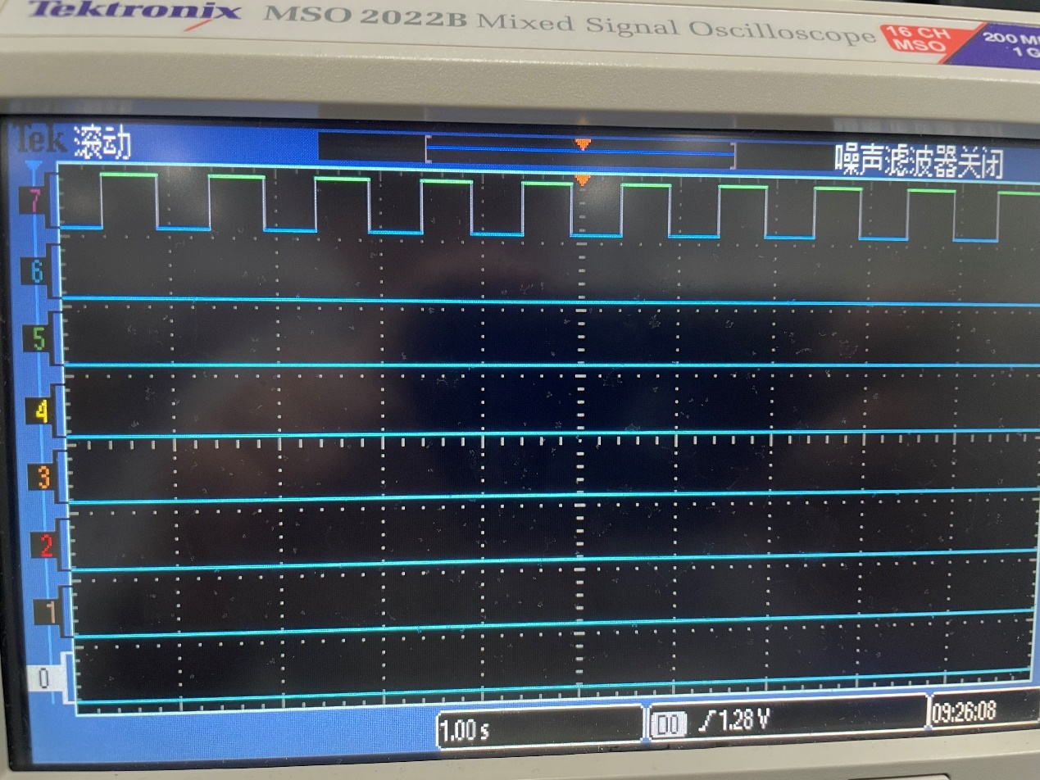
Figure 1 Result of Experiment 1, DS0 flashing at 1Hz.

- Experiment B
2.1 Design
This experiment expanded on Experiment 1 by enabling TIM4 to control LED DS1. The objective was to configure DS1 to flash at 4 Hz and then synchronize it to flash oppositely to DS0.
The TIM4 initialization mirrored TIM3, but the ARR and PSC values were adjusted to generate an 8 Hz interrupt (to toggle at 4 Hz). To achieve the opposite flashing behavior (when DS0 is ON, DS1 is OFF), the logic in the main loop or handler was modified to check the state of DS0 before setting DS1.

  - Result
Figure 2 shows the waveforms of DS0 (controlled by TIM3) and DS1 (controlled by TIM4). The LEDs flash at different rates, and in the synchronized test, they alternate states. 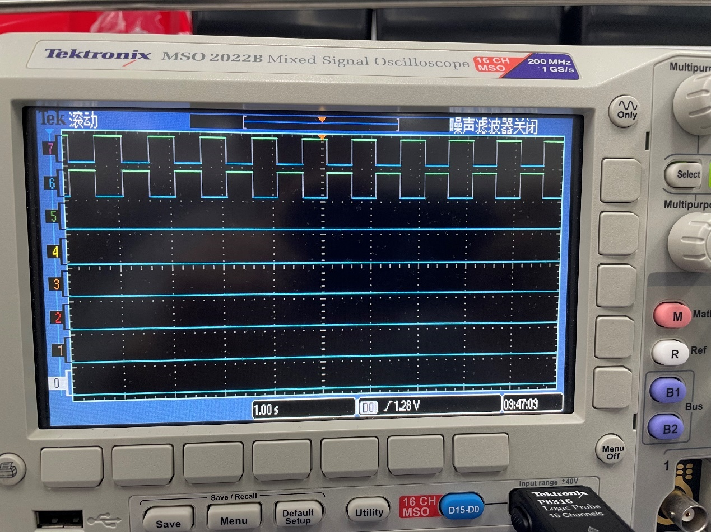
Figure 2 Result of Experiment 2, showing interaction between TIM3 and TIM4.

- Experiment C
3.1 Design
The objective was to use the SysTick timer to generate a 10ms periodic interrupt, acting as a system heartbeat for multi-tasking. ¹⁴
- SysTick Initialization: The SysTick->LOAD register was configured based on the clock source. Using the external reference clock ($F_{CLK}/8=9MHz$), the load value was set to $90,000 - 1$ to achieve a 10ms period (9MHz *10ms = 90,000).
- Handler: The SysTick_Handler increments a global variable task1HeartBeat.
- Task Scheduling: In the main loop, the code checks if task1HeartBeat >= 11. When true, it executes the LED toggling tasks (DS0 at 5Hz, DS1 at 2Hz) and resets the counter.
This demonstrated how a single timer can schedule multiple tasks without blocking delay loops.

For step 4, the code is shown below.
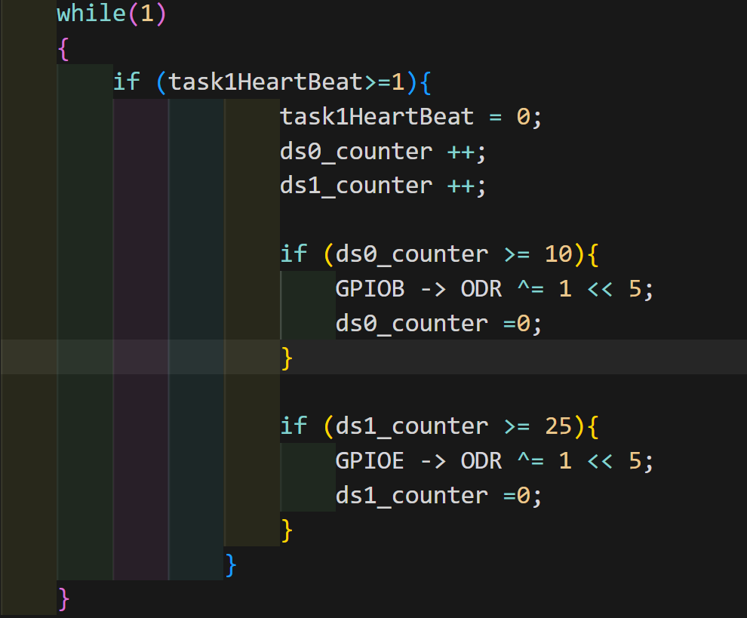
Figure 3 Code for Exp 3 Step 4.
The system utilizes a SysTick timer to trigger an interrupt every 10ms, setting a task1HeartBeat flag that synchronizes the main loop. When this flag is detected, the loop increments two separate counters (ds0_counter and ds1_counter) to track elapsed time. Once these counters reach their specific thresholds—10 ticks for 100ms and 25 ticks for 250ms—the code toggles the corresponding LEDs (DS0 and DS1) and resets the counters, effectively achieving non-blocking, concurrent multitasking that allows the LEDs to blink at different frequencies without pausing the CPU.

  - Result
The LEDs flashed at the programmed frequencies (5Hz and 2Hz) driven by the SysTick heartbeat.

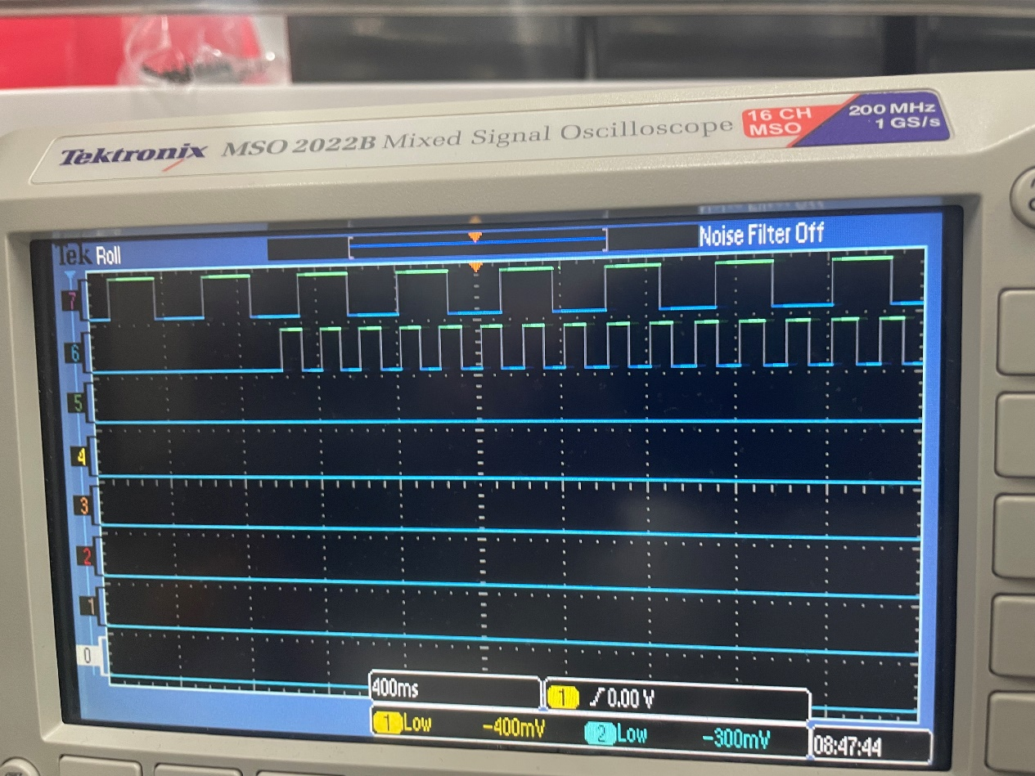
Figure 4 Result of Experiment 3, multi-tasking via SysTick.
- Experiment D
4.1 Design
This experiment implemented Pulse Width Modulation (PWM) using TIM3 to create a "breathing light" effect on DS0. Because DS0 is connected to PB5, and the default TIM3_CH2 is on PA7, a partial remap was required.
The design steps included:
- Enable clocks for GPIOB, AFIO, and TIM3.
- Configure PB5 as Alternate Function Push-Pull output.
- Remap: Set AFIO->MAPR bits to 10 for partial remap of TIM3.
- PWM Mode: Configure TIM3->CCMR1 to set PWM Mode (OC2M = 110 or 111) and enable preload.
- Output Enable: Set the CC2E bit in TIM3->CCER to enable output on Channel 2.
- Loop: In the main loop, the value of TIM3->CCR2 was incremented and decremented continuously to vary the duty cycle from 0 to 100%, causing the LED brightness to fade in and out.

4.2 Result
The voltage output on PB5 observed on the oscilloscope showed a square wave with a continuously varying duty cycle, and the LED DS0 demonstrated a smooth breathing effect.
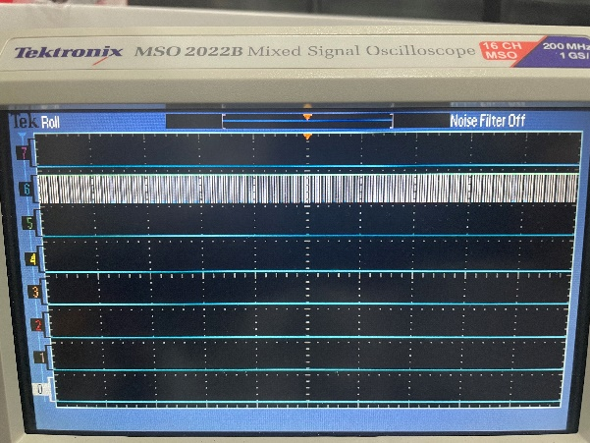 | 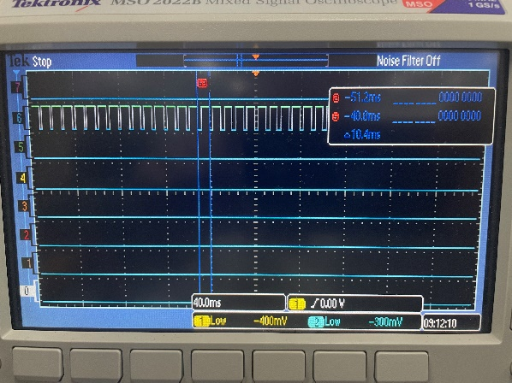
Figure 5 PMW Results for Exp 4

- Experiment E
5.1 Design
The final experiment used TIM3 to read input from a JOYPAD. Instead of polling in the main loop, the reading function was placed inside the TIM3 interrupt handler (running at 100 Hz) to save computational resources.
The JOYPAD uses three pins:
- LAT (PB11): Latch signal.
- CLK (PD3): Clock signal.
- DAT (PB10): Data input.
The JOYPAD_Scan function reads the 8 keys (A, B, SELECT, START, UP, DOWN, LEFT, RIGHT) serially. The main loop checks the returned key value and displays the corresponding name on the TFT-LCD.

  - Result
Figure 6 shows the LCD displaying "UP" when the UP key on the Joypad was pressed.
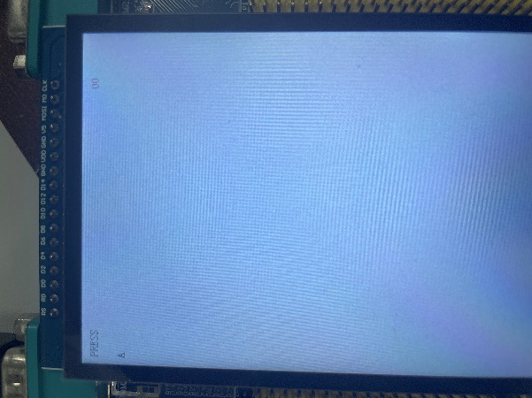 | 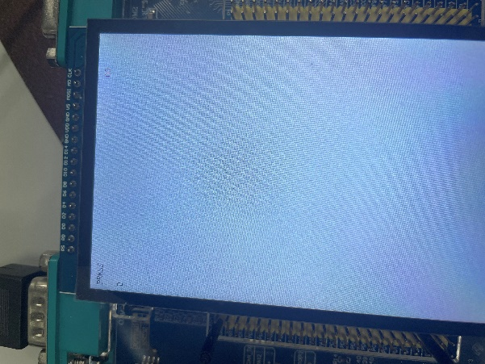
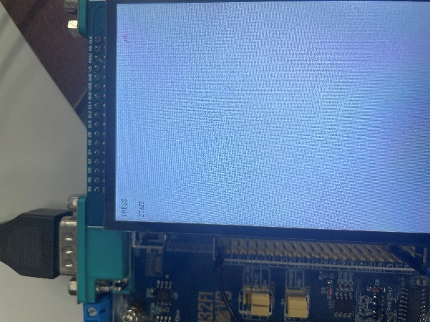 | 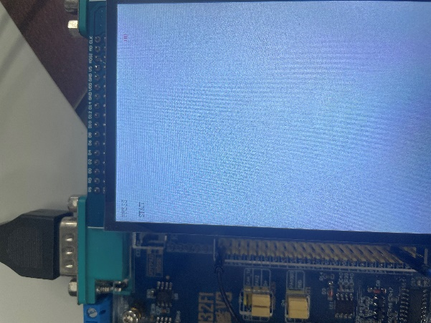
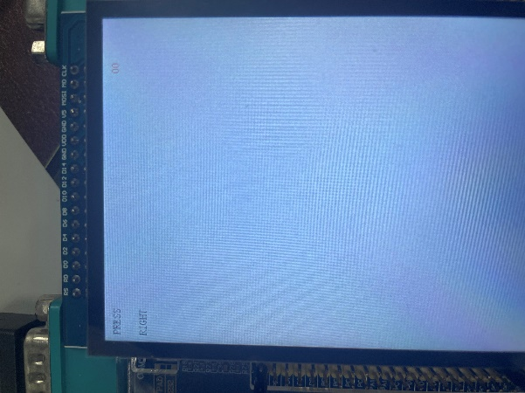 | 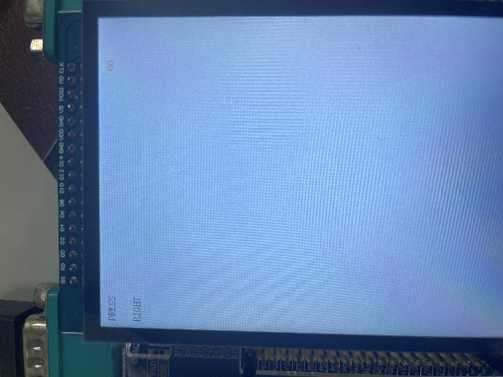
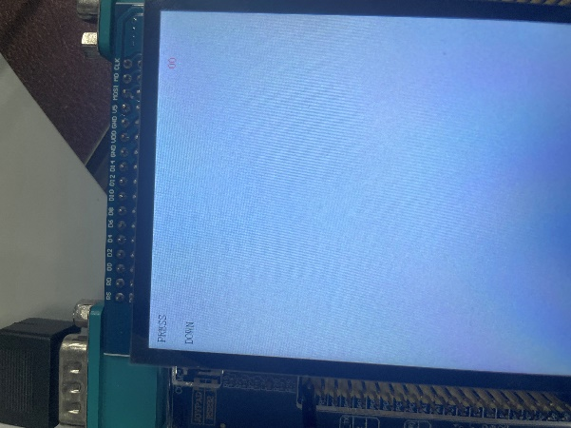 | 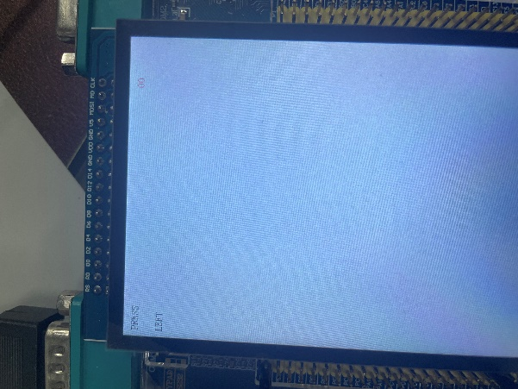
Figure 6 Results of Experiment 5, LCD showing Commands detected from Joypad.
6 Conclusion
In this lab, I successfully learned to configure the Cortex-M3 General Purpose Timers and SysTick timer. I gained practical experience in calculating Prescaler and Auto-Reload values to achieve specific interrupt frequencies. The experiments demonstrated the efficiency of using interrupts for multitasking (SysTick) and input acquisition (Joypad) compared to blocking delays. Furthermore, I learned to generate PWM signals for peripheral control (LED dimming) and utilized GPIO remapping to route timer outputs to specific hardware pins.

